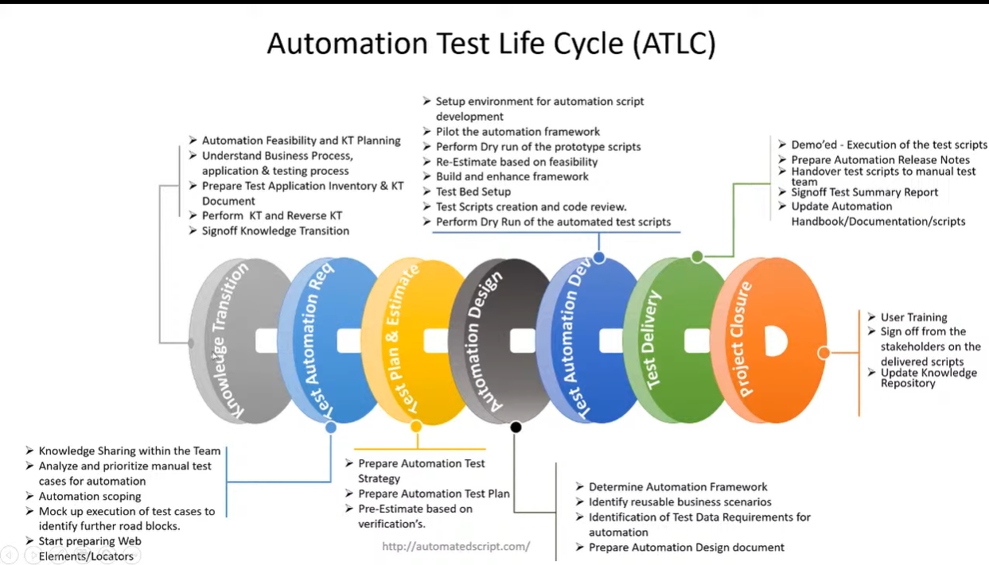

Automated Test Plan
Document Control
Version: 1.0
Date: [Insert Date]

Objective
The objective of this Automated Test Plan is to ensure the effective testing of OpenWeatherMap.org's functionalities in an automated manner. The plan outlines the scope, strategy, and execution details for automated testing.

Project Overview
OpenWeatherMap.org is a web-based platform providing users with real-time weather information and personalized services. The automated testing approach aims to validate the functionality outlined in the FRS and ensure a high level of software quality.

Assumptions
The application is deployed in the testing environment.
Test data is available for various scenarios, including valid and invalid inputs.
The test environment mirrors the production environment in terms of configurations.
Return on Investment (ROI)
The implementation of automated testing will result in increased test coverage, faster feedback cycles, and reduced manual testing efforts. ROI will be measured in terms of reduced defect count, increased release frequency, and improved overall software quality.

Automation Plan
Scope of Automation
The automation scope includes test scenarios related to:

Homepage features
User registration
User login
Test Automation Tools
The chosen test automation tools are [insert tools], selected for their compatibility with the application's technology stack.

Test Data
A comprehensive set of test data, including positive and negative test cases, will be prepared to validate different scenarios.

Automation Design
Test Framework
The test automation framework will be [insert framework], chosen for its scalability, maintainability, and ease of integration with continuous integration systems.

Test Scripts
Test scripts will be developed to cover the functional requirements outlined in the FRS. Test cases will be modular, reusable, and well-documented.

Test Environment Configuration
The test environment will be configured to simulate real-world scenarios, ensuring the reliability of the automated tests.

Automation Execution
Test Execution Schedule
Automated tests will be executed [insert frequency], with a focus on major releases, new feature implementations, and critical bug fixes.

Continuous Integration
Automated tests will be integrated into the continuous integration pipeline to facilitate quick feedback and early detection of issues.

Defect Management
Defects identified during automated testing will be documented in [insert defect tracking tool]. The severity and priority of defects will be assessed and communicated promptly to the development team.

Test Automation Reporting
Test Execution Reports
Detailed test execution reports, including pass/fail status, logs, and screenshots, will be generated and shared after each test cycle.

Test Coverage Reports
Coverage reports will be generated to track the percentage of functional requirements covered by automated tests.

Automation Maintenance
Regular maintenance will be performed to update test scripts in response to changes in application features, ensuring ongoing relevance and accuracy.

